receipt number:
name |  | date of birth
address
phone number |  | e-mail
genres of works
(Check all the items below)

painting□ | sculpture□ | installation□ | drawing□ | performance□ | New-media□ | animation□
photography□ | digital art□ | publication□ | performing art□ | dance□ | others□

submitting of materials
(check all the items below)
application□ | exhibition proposal□ | portfolio□ | artist’s note□ | resume□

notification:
- All the materials will be accepted by mail or e-mail. The accepted documents will be kept in the archive of <Art Space O> without restoration. So please be sure to submit your documents in copies
2. When your documents were received, you will be announced by text messages.

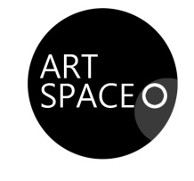 Art Space O Application for Artist Contest

