Membership Information
name |  | date of birth
address
phone |  | e-mail
Choice of Membership Type and Donation
(Thank You For Your Support!)

Tommy Atkins □ | supporting member (occasional) □ | supporting member (periodic) □ |  | (choose one)
Tommy Atkins : | annual dues of 10,000 won
supporting member (occasional) : | amount of donation |  | won
Supporting member (periodic) : | amount of donation |  | won/month
bank:
account number:
account holder:
 | *Please apply automatic transfer in his/her name.

Donation of Works
title
name of the artist
date
size
note for storage

Information of donation receiving bank : Woori Bank, 1002-246-890596(account number), Kim Sung Rea(account holder)
*Donation in cash is also possible when you visit <Art Space O>
*Please send your application form of membership and donation to : artspaceo@naver.com
zip code: 121-894, 377-2 Seokyo-Dong (B 01), Mapo-Gu, Seoul, Korea
information : +82) 070 – 7558 – 4994
date: subscriber: (signature)
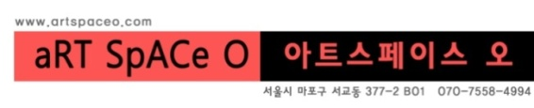
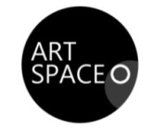
Art Space O Membership & Sponsorship Application

